Country: **Madagascar**

Year: **2016**

Number of Observations: **11284**

Number of Clusters: **5**

Number of variables used: **22**

Distance used: **Hamming**

**Variables used in the algorithm:**

hv206,hv207,hv208,hv210, hv227,hv237,hv243a,hv243b,hv244,hv246,sh122a,sh142,sh146,sh147a,water,toilet,floor,roof,cookfuel,wall

Many of variables were cut out of the final algorithm run due to high collinearity (for instance the hv246a-g, as well as many variables about a campaign and outreach)

**Summary of Top Cluster Configurations (ranked by ASW)**

| **Cluster #** | **ASW** | **Variable 1** | **Variable 2** | **Variable 3** | **Variable 4** |
| --- | --- | --- | --- | --- | --- |
| **1** | 0.833674627234526 | hv206 | hv208 | hv227 | hv243a |
| **2** | 0.827598641767299 | hv206 | hv207 | hv208 | hv243a |
| **3** | 0.82658384266024 | hv206 | hv207 | hv208 | hv227 |
| **4** | 0.824832461258187 | hv206 | hv208 | hv243a | hv243b |
| **5** | 0.824574899771774 | hv206 | hv208 | hv227 | hv243b |
| **6** | 0.823048547084511 | hv206 | hv208 | hv227 | sh122a |
| **7** | 0.819185584650912 | hv206 | hv207 | hv208 | sh142 |
| **8** | 0.818697556543481 | hv206 | hv208 | hv243a | sh122a |
| **9** | 0.817590156819868 | hv206 | hv207 | hv208 | sh122a |
| **10** | 0.815066086786117 | hv206 | hv207 | hv208 | sh147a |

**Distributions of ASW values in all clusters in Madagascar**

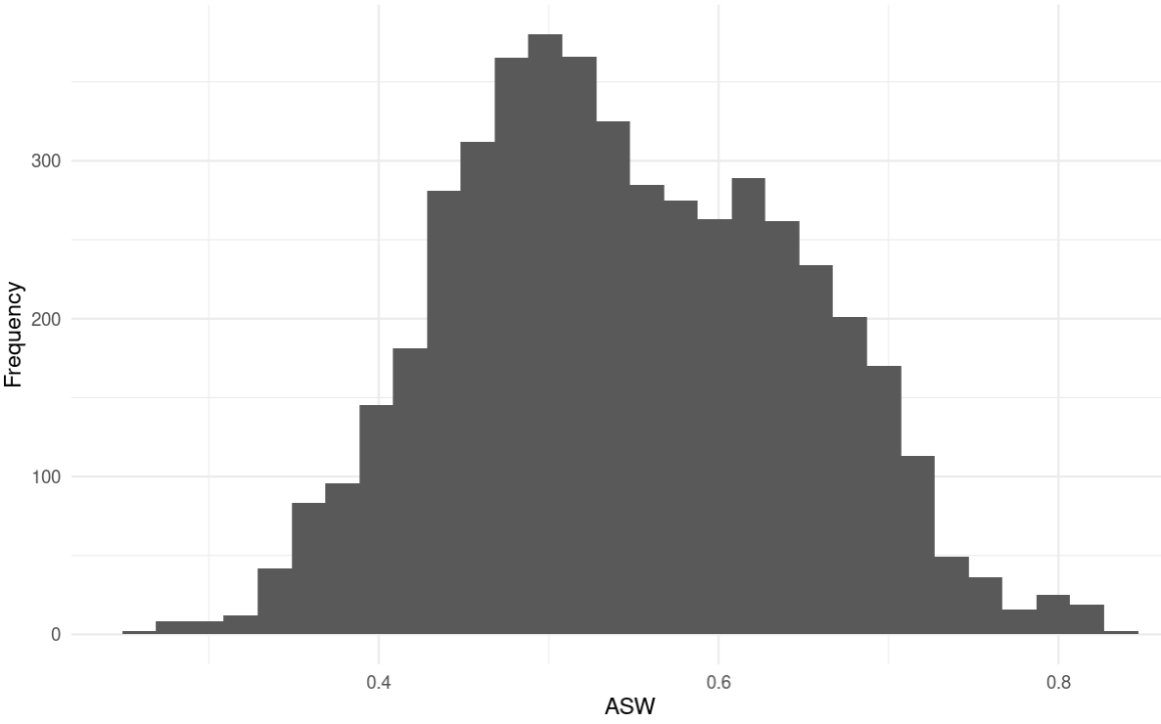

**Marginal Distributions**

| Variable | Description | % time in top clusters | Distribution |
| --- | --- | --- | --- |
| hv206 | Has electricity | 100% | Binary,22.1% 1s (or yes) |
| hv207 | Has radio | 50% | Binary,49.56% 1s (or yes) |
| hv208 | Has television | 100% | Binary,16.8% 1s (or yes) |
| hv227 | Has mosquito bed net for sleeping | 30% | Binary,83.1% 1s (or yes) |
| hv243a | Has mobile telephone | 40% | Binary,34.4% 1s (or yes) |
| hv243b | Has watch | 20% | Binary,34.2% 1s (or yes) |
| sh122a | Anyone came to spray walls | 30% | Binary,14.9% 1s (or yes) |
| sh142 | Have net not being used for sleeping | 10% | Binary,25.9% 1s (or yes) |
| sh147a | Have a net texture/color preference | 10% | Binary,54.5% 1s (or yes) |

**Summary of variable distributions in top clusters**

Currently our method is choosing five distinct clusters of individuals within each cluster variable configuration. Here are the medioids for each of these five clusters:

**Cluster #1 Configuration**

| **Config#** | **Node** | **hv206** | **hv208** | **hv227** | **hv243a** | **Proportion** |
| --- | --- | --- | --- | --- | --- | --- |
| **1** | 1 | 0 | 0 | 0 | 1 | 4.13% |
| **2** | 1 | 0 | 1 | 0 | 1 |
| **3** | 1 | 1 | 0 | 0 | 1 |
| **4** | 2 | 0 | 1 | 1 | 1 | 19.67% |
| **5** | 2 | 1 | 0 | 1 | 1 |
| **6** | 2 | 1 | 1 | 0 | 0 |
| **7** | 2 | 1 | 1 | 0 | 1 |
| **8** | 2 | 1 | 1 | 1 | 0 |
| **9** | 2 | 1 | 1 | 1 | 1 |
| **10** | 3 | 0 | 0 | 1 | 1 | 12.18% |
| **11** | 4 | 0 | 0 | 0 | 0 | 10.71% |
| **12** | 4 | 0 | 1 | 0 | 0 |
| **13** | 4 | 1 | 0 | 0 | 0 |
| **14** | 5 | 0 | 0 | 1 | 0 | 53.31% |
| **15** | 5 | 0 | 1 | 1 | 0 |
| **16** | 5 | 1 | 0 | 1 | 0 |

**Validation of Top Cluster with Chi-Sq Distribution**

Note that in the tables, the rows are the validation variables, and the columns are the node number from the cluster distributions in the table above.